K - Means Clustering
Instructions:
Please share your answers filled in-line in the word document. Submit code separately wherever applicable.

Please ensure you update all the details:
Name: _g Rupak____________ Batch ID: __07/05_________
Topic: K Means Clustering

Grading Guidelines:
1. An assignment submission is considered complete only when correct and executable code(s) are submitted along with the documentation explaining the method and results. Failing to submit either of those will be considered an invalid submission and will not be considered for evaluation.
2. Assignments submitted after the deadline will affect your grades.

Grading:
Ans | Date |  |  | Ans | Date
Correct | On time | A | 100
80% & above | On time | B | 85 | Correct | Late
50% & above | On time | C | 75 | 80% & above | Late
50% & below | On time | D | 65 | 50% & above | Late
 |  | E | 55 | 50% & below
Copied/No Submission |  | F | 45

- Grade A: (>= 90): When all assignments are submitted on or before the given deadline.
- Grade B: (>= 80 and < 90):
  - When assignments are submitted on time but less than 80% of problems are completed.
(OR)
  - All assignments are submitted after the deadline.

- Grade C: (>= 70 and < 80):
  - When assignments are submitted on time but less than 50% of the problems are completed.
(OR)
  - Less than 80% of problems in the assignments are submitted after the deadline.

- Grade D: (>= 60 and < 70):
  - Assignments submitted after the deadline and with 50% or less problems.

- Grade E: (>= 50 and < 60):
  - Less than 30% of problems in the assignments are submitted after the deadline.
(OR)
  - Less than 30% of problems in the assignments are submitted before the deadline.

- Grade F: (< 50): No submission (or) malpractice.

Hints:
1. Business Problem
  - What is the business objective?
  - Are there any constraints?

2. Work on each feature of the dataset to create a data dictionary as displayed in the below image:
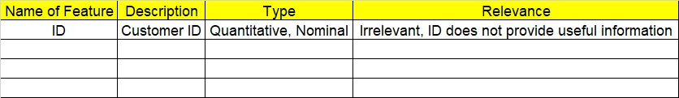

3. Data Pre-processing
3.1 Data Cleaning, Feature Engineering, etc.
4. Exploratory Data Analysis (EDA):
4.1. Summary.
4.2. Univariate analysis.
4.3. Bivariate analysis.

5. Model Building
5.1 Build the model on the scaled data (try multiple options).
5.2 Perform K- means clustering and obtain optimum number of clusters using scree plot.
5.3 Validate the clusters (try with different number of clusters) – label the clusters and derive insights (compare the results from multiple approaches).
6. Write about the benefits/impact of the solution - in what way does the business (client) benefit from the solution provided?

Problem Statements:
- Perform K means clustering on the airlines dataset to obtain optimum number of clusters. Draw the inferences from the clusters obtained. Refer to EastWestAirlines.xlsx dataset.

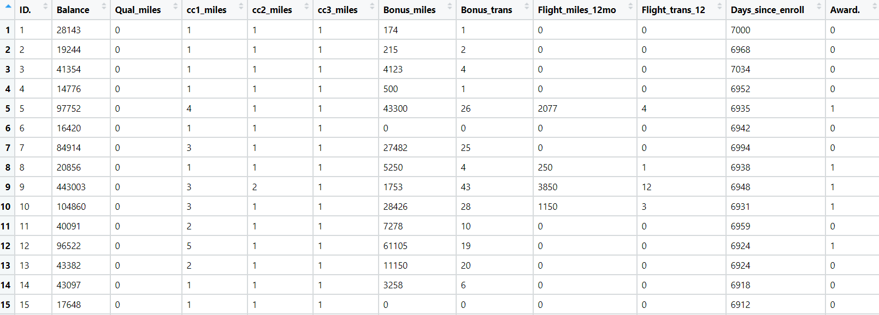
import pandas as pd
import numpy as np
import matplotlib.pylab as plt
from sklearn.cluster import KMeans
# from scipy.spatial.distance import cdist
# Kmeans on Data set
xls = pd.ExcelFile("D:/Data Science/ASSIGNMENT/Assignments 7 kmeans,PCA,association rule/kmeans/EastWestAirlines (1).Xlsx")
xls.sheet_names
df = pd.read_excel(xls,sheet_name = 'data')
df.describe()
data = df.drop(["ID#"], axis = 1)
data.describe()
data.info()
# Normalization function
def norm_func(i):
x = (i - i.min()) / (i.max() - i.min())
return (x)
# Normalized data frame (considering the numerical part of data)
df_norm = norm_func(data.iloc[:, 1:])
###### scree plot or elbow curve ############
TWSS = []
k = list(range(2, 9))
for i in k:
kmeans = KMeans(n_clusters = i)
kmeans.fit(df_norm)
TWSS.append(kmeans.inertia_)
TWSS
# Scree plot
plt.plot(k, TWSS, 'ro-');plt.xlabel("No_of_Clusters");plt.ylabel("total_within_SS")
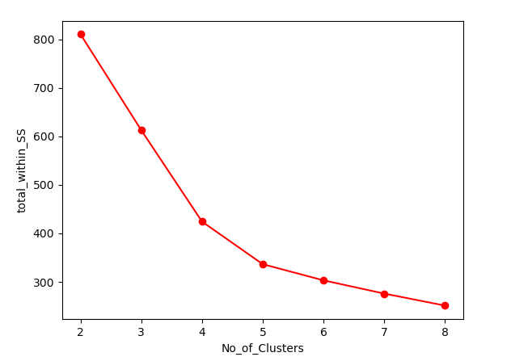

# Selecting 3 clusters from the above scree plot
model = KMeans(n_clusters = 3)
model.fit(df_norm)
model.labels_ # getting the labels of clusters assigned to each row
mb = pd.Series(model.labels_) # converting numpy array into pandas series object
data['clust'] = mb # creating a new column and assigning it to new column
data.head()
df_norm.head()
data = data.iloc[:,[11,0,1,2,3,4,5,6,7,8,9,10]]
data.head()
data.iloc[:, 1:].groupby(data.clust).mean()
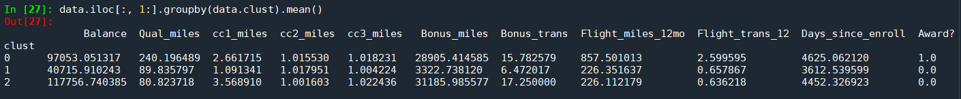
data.to_csv("EastWestAirlines1.csv", encoding = "utf-8")
import os
os.getcwd()

- Perform clustering for the crime data and identify the number of clusters formed and draw inferences. Refer to crime_data.csv dataset.

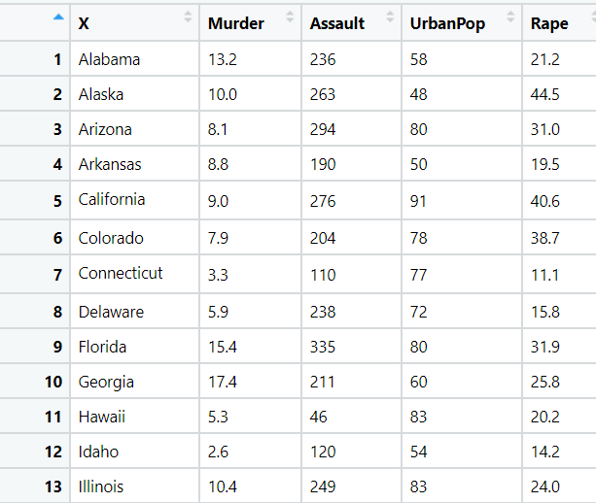
import pandas as pd
import numpy as np
import matplotlib.pylab as plt
from sklearn.cluster import KMeans
# from scipy.spatial.distance import cdist
# Kmeans on Data set
data = pd.read_excel("D:/Data Science/ASSIGNMENT/Assignments 7 kmeans,PCA,association rule/kmeans/crime_data (1).xlsx")
data.describe()
data.info()
# Normalization function
def norm_func(i):
x = (i - i.min()) / (i.max() - i.min())
return (x)
# Normalized data frame (considering the numerical part of data)
df_norm = norm_func(data.iloc[:, 1:])
###### scree plot or elbow curve ############
TWSS = []
k = list(range(2, 9))
for i in k:
kmeans = KMeans(n_clusters = i)
kmeans.fit(df_norm)
TWSS.append(kmeans.inertia_)
TWSS
# Scree plot
plt.plot(k, TWSS, 'ro-');plt.xlabel("No_of_Clusters");plt.ylabel("total_within_SS")
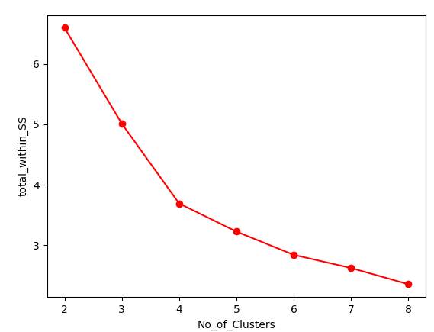
# Selecting 3 clusters from the above scree plot
model = KMeans(n_clusters = 3)
model.fit(df_norm)
model.labels_ # getting the labels of clusters assigned to each row
mb = pd.Series(model.labels_) # converting numpy array into pandas series object
data['clust'] = mb # creating a new column and assigning it to new column
data.head()
df_norm.head()
data = data.iloc[:,[0,5,1,2,3,4]]
data.head()
data.iloc[:, 2:].groupby(data.clust).mean()
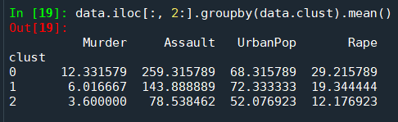

data.to_csv("crime1.csv", encoding = "utf-8")
import os
os.getcwd()
- Analyze the information given in the following ‘Insurance Policy dataset’ to create clusters of persons falling in the same type. Refer to Insurance Dataset.csv

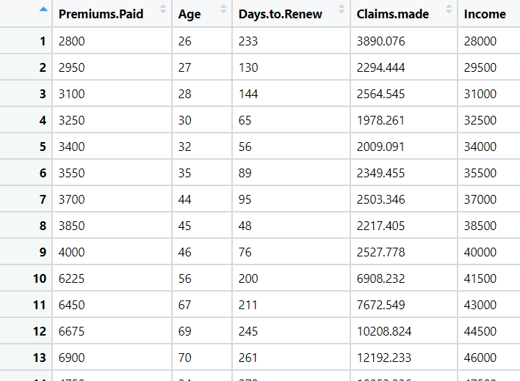

import pandas as pd
import numpy as np
import matplotlib.pylab as plt
from sklearn.cluster import KMeans
# from scipy.spatial.distance import cdist
# Kmeans on Data set
data = pd.read_excel("D:/Data Science/ASSIGNMENT/Assignments 7 kmeans,PCA,association rule/kmeans/Insurance Dataset.xlsx")
data.describe()
data.info()
# Normalization function
def norm_func(i):
x = (i - i.min()) / (i.max() - i.min())
return (x)
# Normalized data frame (considering the numerical part of data)
df_norm = norm_func(data.iloc[:, 0:])
###### scree plot or elbow curve ############
TWSS = []
k = list(range(2, 9))
for i in k:
kmeans = KMeans(n_clusters = i)
kmeans.fit(df_norm)
TWSS.append(kmeans.inertia_)
TWSS
# Scree plot
plt.plot(k, TWSS, 'ro-');plt.xlabel("No_of_Clusters");plt.ylabel("total_within_SS")

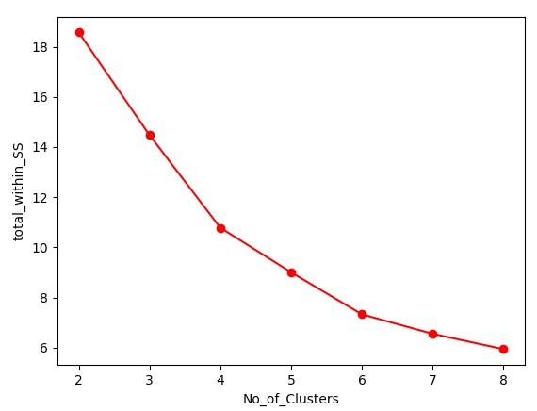
# Selecting 3 clusters from the above scree plot
model = KMeans(n_clusters = 3)
model.fit(df_norm)
model.labels_ # getting the labels of clusters assigned to each row
mb = pd.Series(model.labels_) # converting numpy array into pandas series object
data['clust'] = mb # creating a new column and assigning it to new column

data.head()
df_norm.head()
data = data.iloc[:,[5,0,1,2,3,4]]
data.head()
data.iloc[:, 1:].groupby(data.clust).mean()
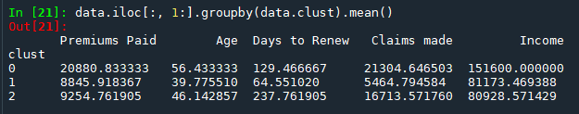
data.to_csv("Insurance1.csv", encoding = "utf-8")
import os
os.getcwd()

- Perform clustering analysis on the telecom dataset. The data is a mixture of both categorical and numerical data. It consists of the number of customers who churn. Derive insights and get possible information on factors that may affect the churn decision. Refer to Telco_customer_churn.xlsx dataset.
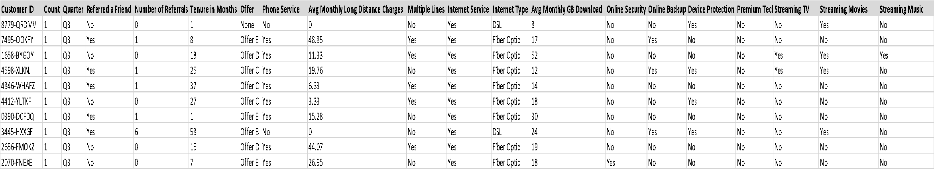

import pandas as pd
import numpy as np
import matplotlib.pylab as plt

from sklearn.cluster import KMeans
# from scipy.spatial.distance import cdist

# Kmeans on Data set
data = pd.read_excel("D:/Data Science/ASSIGNMENT/Assignments 7 kmeans,PCA,association rule/kmeans/Telco_customer_churn (1).xlsx")

data.describe()

data.info()

#droping Count and Quarter column
df = data.drop(["Quarter","Count"], axis=1)

# Label Encoder
from sklearn.preprocessing import LabelEncoder
# creating instance of labelencoder
labelencoder = LabelEncoder()
df['Referred a Friend']= labelencoder.fit_transform(df['Referred a Friend'])
df['Offer']= labelencoder.fit_transform(df['Offer'])
df['Phone Service']= labelencoder.fit_transform(df['Phone Service'])
df['Multiple Lines']= labelencoder.fit_transform(df['Multiple Lines'])
df['Internet Service']= labelencoder.fit_transform(df['Internet Service'])
df['Internet Type']= labelencoder.fit_transform(df['Internet Type'])
df['Online Security']= labelencoder.fit_transform(df['Online Security'])
df['Online Security']= labelencoder.fit_transform(df['Online Security'])
df['Online Backup']= labelencoder.fit_transform(df['Online Backup'])
df['Device Protection Plan']= labelencoder.fit_transform(df['Device Protection Plan'])
df['Premium Tech Support']= labelencoder.fit_transform(df['Premium Tech Support'])
df['Streaming TV']= labelencoder.fit_transform(df['Streaming TV'])
df['Streaming Movies']= labelencoder.fit_transform(df['Streaming Movies'])
df['Unlimited Data']= labelencoder.fit_transform(df['Unlimited Data'])
df['Contract']= labelencoder.fit_transform(df['Contract'])
df['Paperless Billing']= labelencoder.fit_transform(df['Paperless Billing'])
df['Payment Method']= labelencoder.fit_transform(df['Payment Method'])
df['Streaming Music']= labelencoder.fit_transform(df['Streaming Music'])
df.info()
# Normalization function
def norm_func(i):
x = (i - i.min()) / (i.max() - i.min())
return (x)

# Normalized data frame (considering the numerical part of data)
df_norm = norm_func(df.iloc[:, 1:])

###### scree plot or elbow curve ############
TWSS = []
k = list(range(2, 9))

for i in k:
kmeans = KMeans(n_clusters = i)
kmeans.fit(df_norm)
TWSS.append(kmeans.inertia_)

TWSS
# Scree plot
plt.plot(k, TWSS, 'ro-');plt.xlabel("No_of_Clusters");plt.ylabel("total_within_SS")
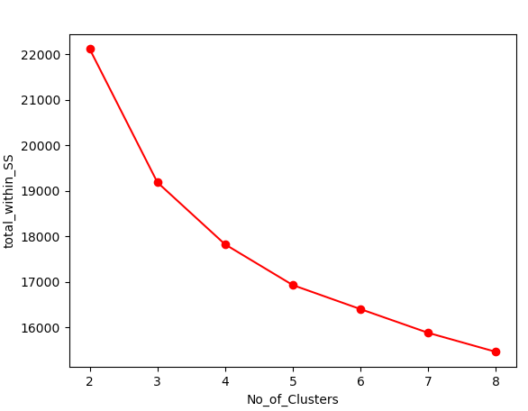
# Selecting 3 clusters from the above scree plot
model = KMeans(n_clusters = 3)
model.fit(df_norm)

model.labels_ # getting the labels of clusters assigned to each row
mb = pd.Series(model.labels_) # converting numpy array into pandas series object
df['clust'] = mb # creating a new column and assigning it to new column
df.head()
df_norm.head()
data1 = df.iloc[:,[0,28,1,2,3,4,5,6,7,8,9,10,11,12,13,14,15,16,17,18,19,20,21,22,23,24,25,26,27]]
data1.head()
data1.iloc[:, 2:].groupby(df.clust).mean()
data1.to_csv("Telcom1.csv", encoding = "utf-8")
import os
os.getcwd()

- Perform clustering on mixed data. Convert the categorical variables to numeric by using dummies or label encoding and perform normalization techniques. The dataset has the details of customers related to their auto insurance. Refer to Autoinsurance.csv dataset.
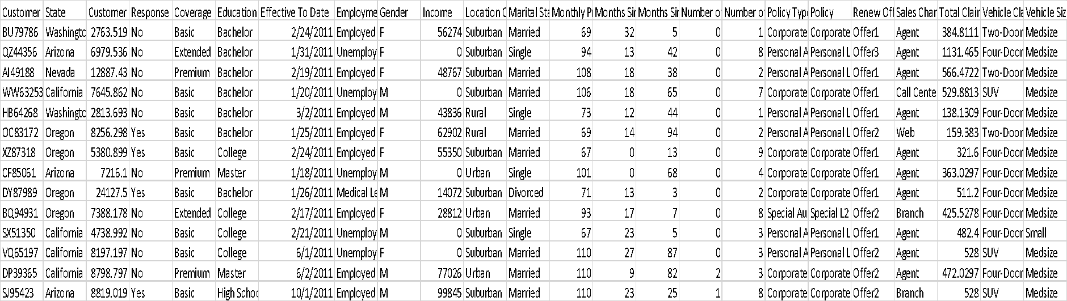
import pandas as pd
import numpy as np
import matplotlib.pylab as plt
from sklearn.cluster import KMeans
# from scipy.spatial.distance import cdist
# Kmeans on Data set
data = pd.read_excel("D:/Data Science/ASSIGNMENT/Assignments 7 kmeans,PCA,association rule/kmeans/AutoInsurance (1).xlsx")
data.describe()
data.info()
#droping Effective To Date column
df = data.drop(["Effective To Date"], axis=1)
# Label Encoder
from sklearn.preprocessing import LabelEncoder
# creating instance of labelencoder
labelencoder = LabelEncoder()
df['State']= labelencoder.fit_transform(df['State'])
df['Education']= labelencoder.fit_transform(df['Education'])
df['Response']= labelencoder.fit_transform(df['Response'])
df['Coverage']= labelencoder.fit_transform(df['Coverage'])
df['EmploymentStatus']= labelencoder.fit_transform(df['EmploymentStatus'])
df['Gender']= labelencoder.fit_transform(df['Gender'])
df['Location Code']= labelencoder.fit_transform(df['Location Code'])
df['Marital Status']= labelencoder.fit_transform(df['Marital Status'])
df['Policy Type']= labelencoder.fit_transform(df['Policy Type'])
df['Policy']= labelencoder.fit_transform(df['Policy'])
df['Renew Offer Type']= labelencoder.fit_transform(df['Renew Offer Type'])
df['Sales Channel']= labelencoder.fit_transform(df['Sales Channel'])
df['Vehicle Class']= labelencoder.fit_transform(df['Vehicle Class'])
df['Vehicle Size']= labelencoder.fit_transform(df['Vehicle Size'])

df.isnull().sum()
df.info()
# Normalization function
def norm_func(i):
x = (i - i.min()) / (i.max() - i.min())
return (x)

# Normalized data frame (considering the numerical part of data)
df_norm = norm_func(df.iloc[:, 1:])
###### scree plot or elbow curve ############
TWSS = []
k = list(range(2, 9)
for i in k:
kmeans = KMeans(n_clusters = i)
kmeans.fit(df_norm)
TWSS.append(kmeans.inertia_)
TWSS
# Scree plot
plt.plot(k, TWSS, 'ro-');plt.xlabel("No_of_Clusters");plt.ylabel("total_within_SS")
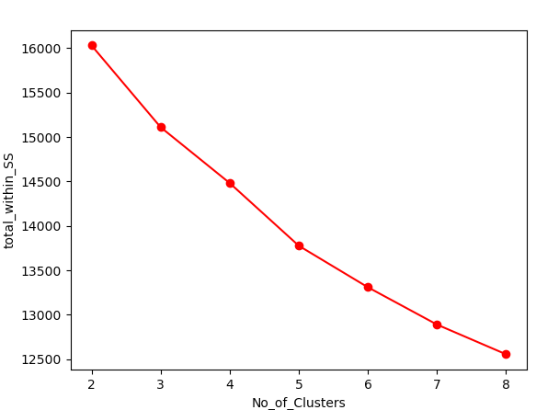

# Selecting 3 clusters from the above scree plot
model = KMeans(n_clusters = 3)
model.fit(df_norm)
model.labels_ # getting the labels of clusters assigned to each row
mb = pd.Series(model.labels_) # converting numpy array into pandas series object
df['clust'] = mb # creating a new column and assigning it to new column
df.head()
df_norm.head()
data1 = df.iloc[:,[0,23,1,2,3,4,5,6,7,8,9,10,11,12,13,14,15,16,17,18,19,20,21,22]]
data1.head()
data1.iloc[:, 2:].groupby(df.clust).mean()
data1.to_csv("AutoInsurance1.csv", encoding = "utf-8")
import os
os.getcwd()

